Getting Started with Quicken® Essentials for Mac®

Before you can download your transactions with Quicken Essentials, you must have
Internet access, your Customer ID, and PIN.

Your Quicken Customer ID and PIN are the same as you use to log in to Bank of
Botetourt’s Online Banking website.

For step-by-step help with an online task, choose the Help menu Quicken Essentials
Help/Basics/

This guide includes the following sections:

• Downloading the Latest Quicken Update

• Creating a New Account and Downloading via Direct Connect

• Creating a New Account and Downloading via Web Connect

• Keeping your Quicken Accounts up to Date

• For Additional Help

DOWNLOADING THE LATEST QUICKEN UPDATE

1. From the Quicken menu choose Check for Updates.

2. Follow the on-screen instructions.

CREATING A NEW ACCOUNT AND DOWNLOADING VIA DIRECT CONNECT

Please see related screen shots below the steps:

1. From the Quicken menu choose Account/New (from the submenu choose the account type such as Checking, Savings, or other)

2. In the Add Account window that appears, start typing Bank of Botetourt. Select Bank of Botetourt in the list, and click Options

3. Select the Direct Connect Radio Button and Click Continue.

4. Log into your Intuit Account first; enter your Member ID and Password, and click Continue. Then enter your Customer ID and Password for online access at your Financial Institution.

5. Uncheck any account that you do not want to set up.

6. Click Continue when you have specified how Quicken should handle each online account.

7. Click OK to view the account registers.

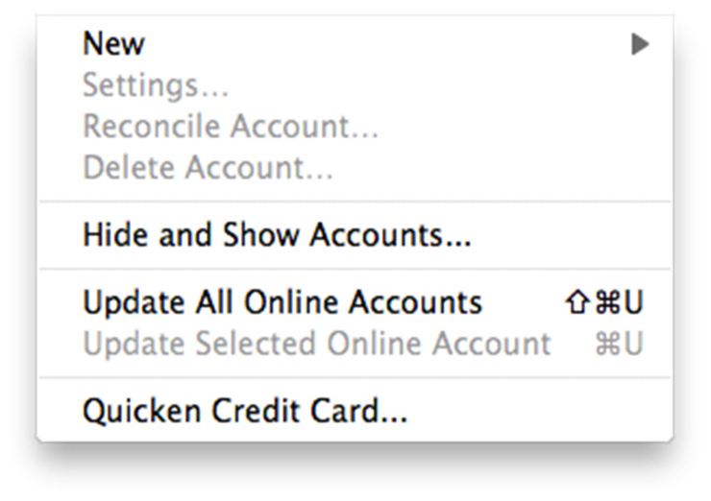

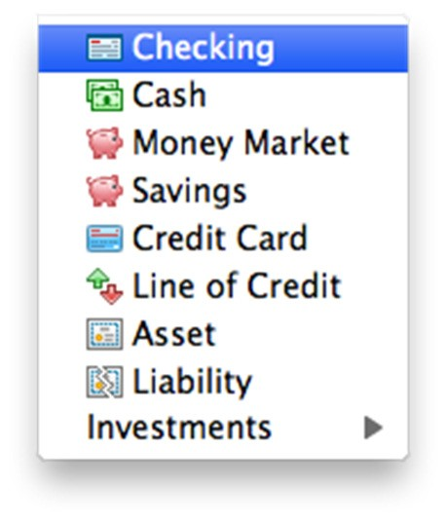

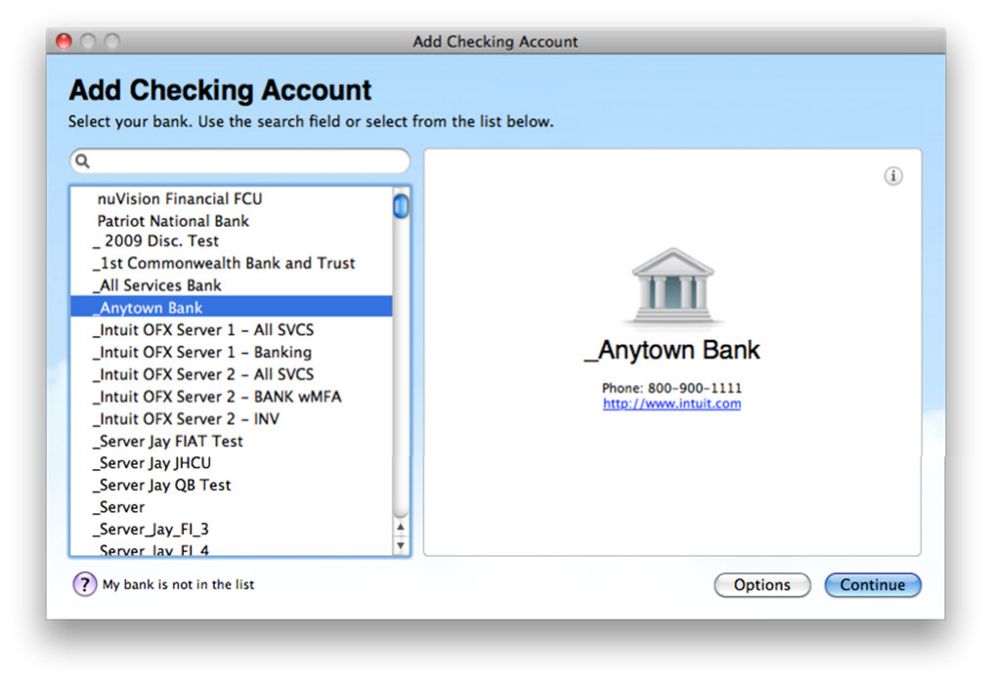

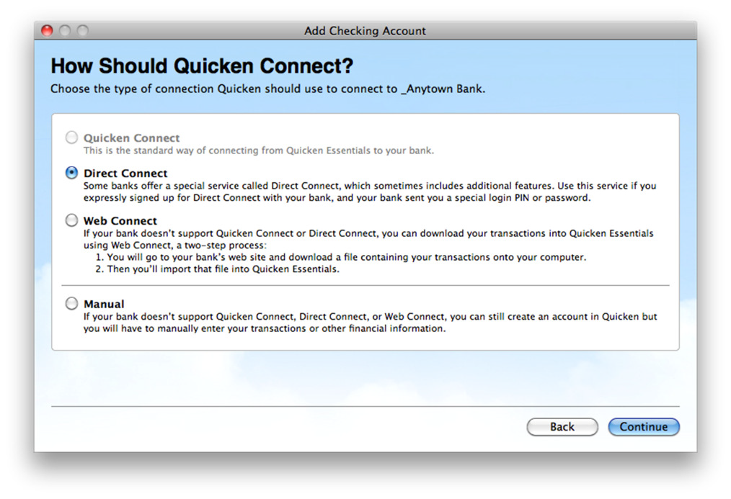

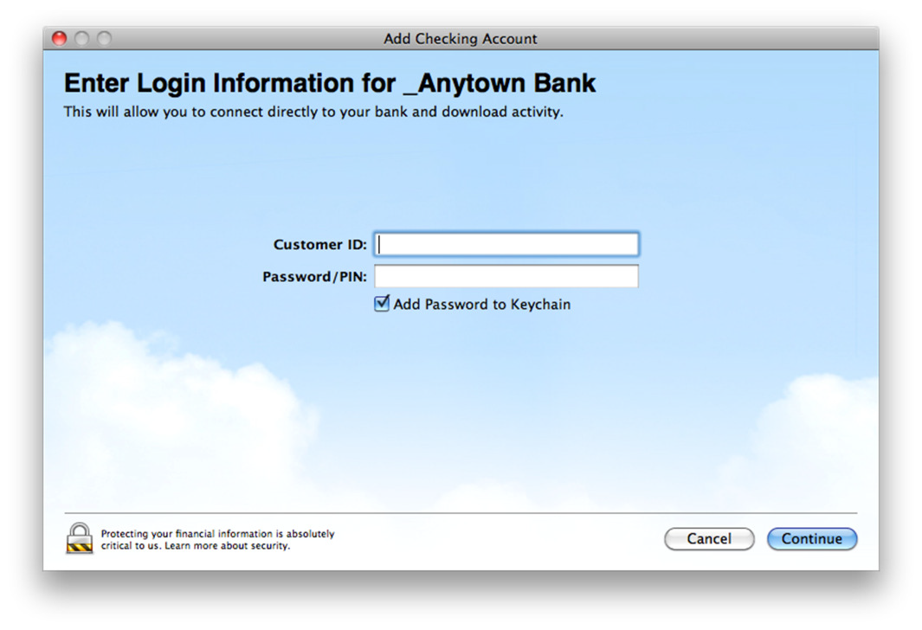

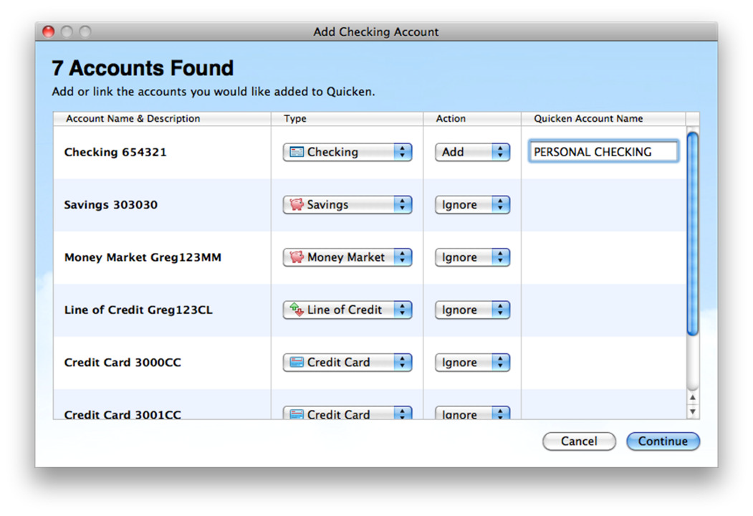

CREATING A NEW ACCOUNT AND DOWNLOADING VIA WEB CONNECT

Please see related screen shots below the steps:

Before you can download your transactions with Quicken Essentials, you must have Internet access, your
Customer ID, and PIN.

Next step: login to your financial institution online banking web site and follow the steps to download transactions into Quicken.

Save the downloaded Web Connect file (With extension .QFX)

1. Choose the Quicken menu /Account/New (from the submenu choose the account type such as Checking, Savings, or other)

2. In the Add Account window that appears, start typing Bank of Botetourt. Select Bank of Botetourt in the list, and click Continue.

3. Drag and Drop the downloaded Web Connect .QFX file to the designated area in the Download
Transactions Quicken window.

4. Click Continue

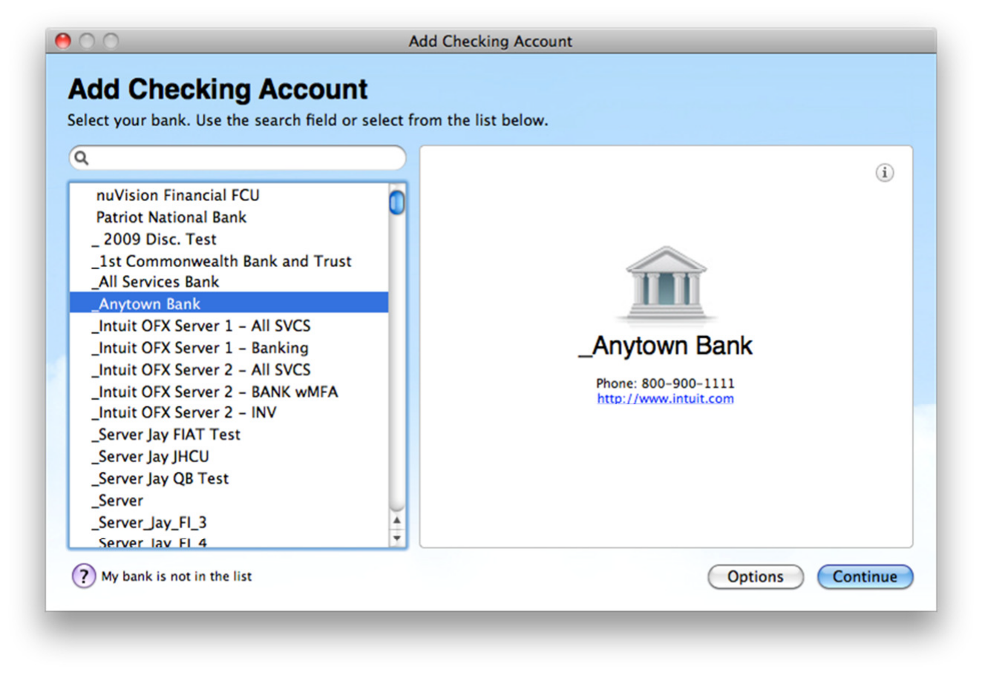

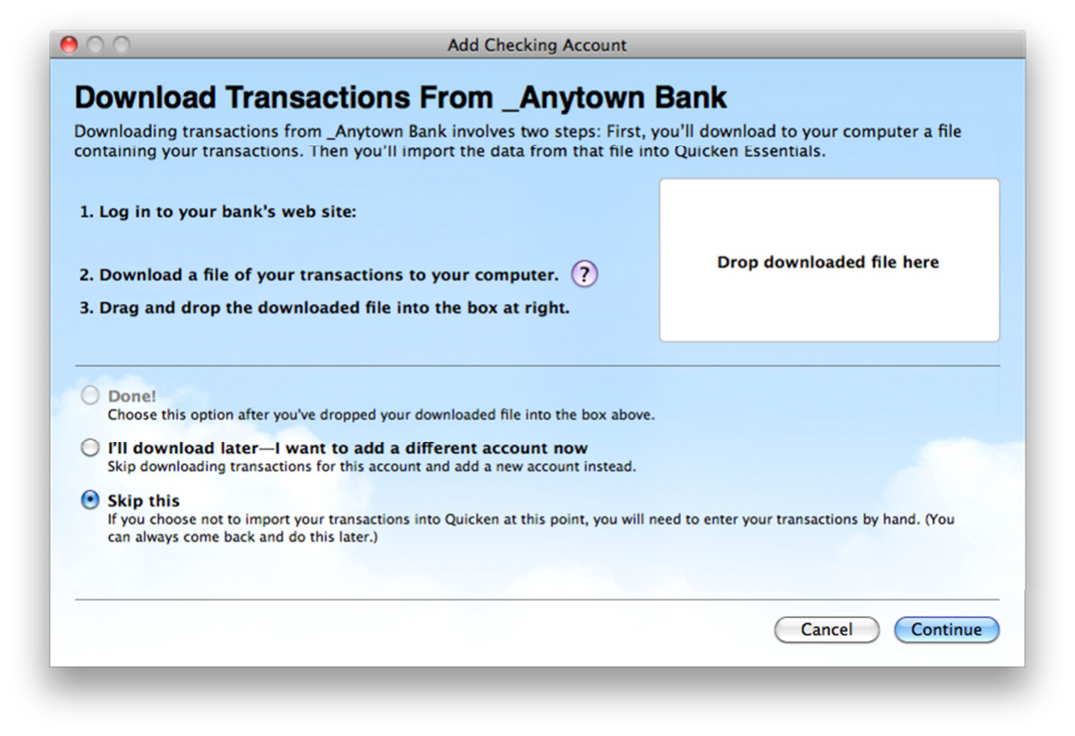

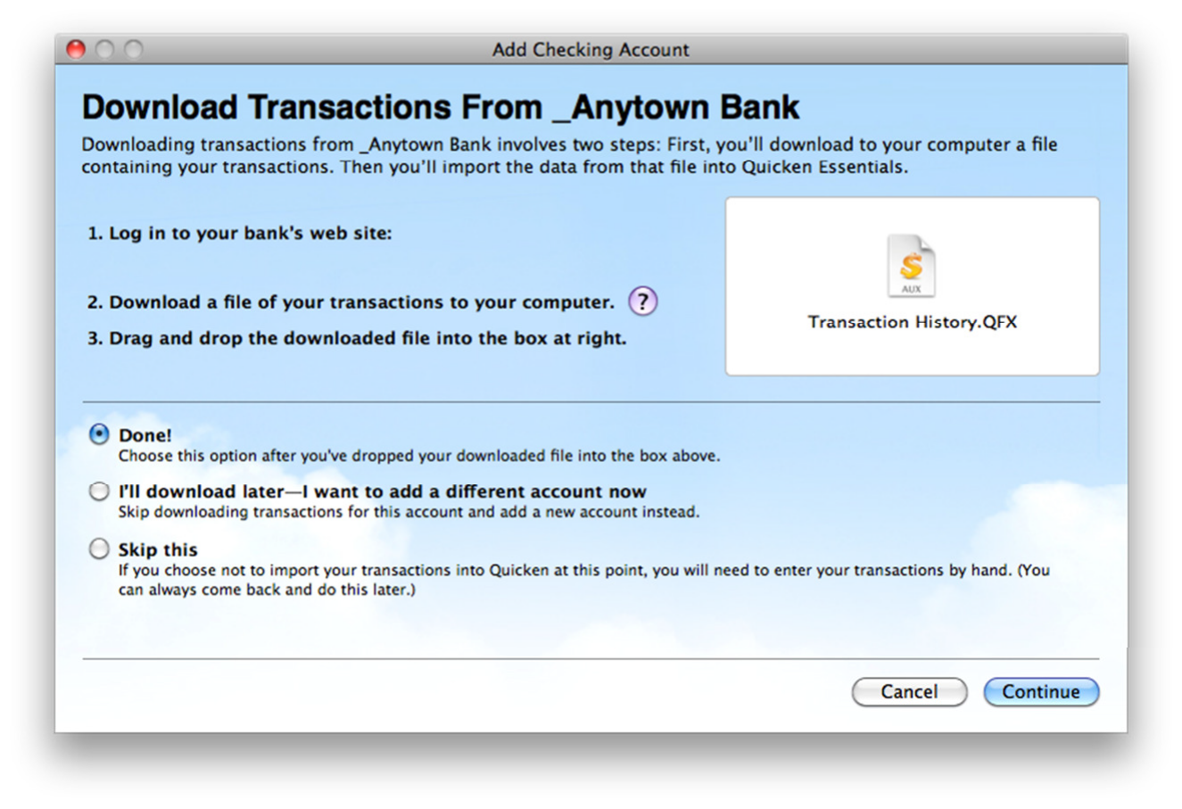

KEEPING YOUR QUICKEN ACCOUNTS UP TO DATE

To download Transactions into your Account Register:

1. Choose Accounts/Update Selected Online Account.

2. Enter Password in the Pop-up dialog box.

3. Click OK

Quicken connects to the Internet and downloads your transactions for all the online accounts at Bank of
Botetourt that you have set up in Quicken.

CONGRATULATIONS! YOU ARE SET UP AND READY TO USE QUICKEN ESSENTIALS

If you have any questions regarding these instructions, you may refer to: http://www.intuit.com/support/quicken.

