QuickBooks Mac 2013 Getting
Started Guide

Financial Institution Support - OFX Connectivity Group

Table of Contents

QUICKBOOKS 2013 FOR MAC GETTING STARTED GUIDE ........................................ 3

ABOUT THIS GUIDE .................................................................................................. 3

QUICKBOOKS 2013 DOWNLOADED TRANSACTIONS INTERFACE ......................................... 3

WHAT YOU NEED TO GET STARTED......................................................................... 4

SET UP AN ACCOUNT FOR ONLINE BANKING (DIRECT CONNECT)........................................ 4

SET UP AN ACCOUNT FOR ONLINE BANKING (WEB CONNECT) ........................................... 6

UPDATING ACCOUNTS .............................................ERROR! BOOKMARK NOT DEFINED.

UPDATING AN ACCOUNT (DIRECT CONNECT) ................................................................. 8

UPDATING AN ACCOUNT (WEB CONNECT) ................................................................... 10

SPECIAL NOTE 1: MATCHING AND ADDING TRANSACTIONS ............................... 11

MATCH DOWNLOADED TRANSACTIONS................................... ERROR! BOOKMARK NOT DEFINED.

SPECIAL NOTE 2: OTHER RESOURCES .............................................................. 112

RESOURCES FOR MORE INFORMATION ......................................................................... 12

QuickBooks 2013 for Mac Getting Started Guide

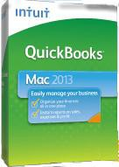Thank you for choosing QuickBooks!

About this Guide

This guide helps you get started with QuickBooks as quickly as possible. You’ll
learn:

• What you will need to get started

• How to set up an account for online banking (Direct Connect)

• How to set up an account for online banking (Web Connect)

• How to update an account (Direct Connect)

• How to update an account (Web Connect)

QuickBooks 2013 Downloaded Transactions Interface

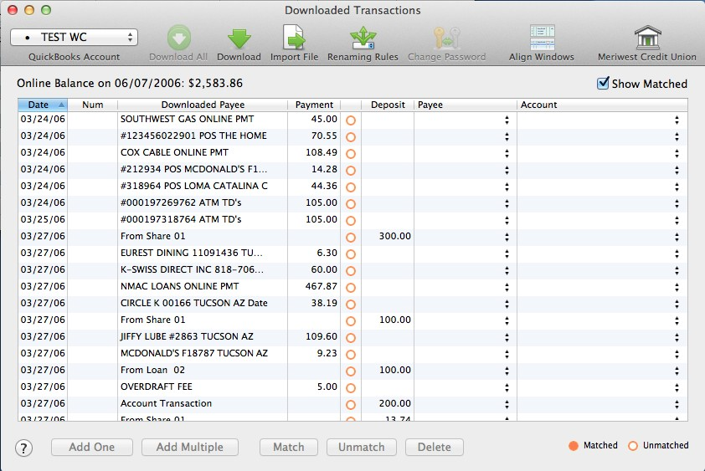The QuickBooks 2013 Online Banking center is a one-stop-shop to download your online banking activity and match transactions.

Select Financial Institution
Begin Automated Update

Import Web Connect File

Open Financial Institution
Website

What You Need to Get Started

Before you enable your QuickBooks accounts to download transactions and make online payments, you may need to contact your financial institution (FI) for the following information:

• Customer ID

• Personal Identification Number (PIN) or password

Note: For QuickBooks Web Connect accounts, the customer ID and PIN/password you will need are the same as the ones you use currently to log into the financial institution website. For Direct Connect they may be the same or not. Please contact your financial institution to verify your Direct Connect login information.

It is recommended that you take these steps first:

• Back Up Your QuickBooks Data File.

For instructions to back up your data file, choose the Help menu and use the Search bar available at the top. Search for Back Up and follow the instructions on screen. The first time you do a backup, QuickBooks will guide you through setting backup preferences.

• Download the latest QuickBooks update.

For instructions to download an update, choose Help menu and use the Search bar available at the top. Search for Update QuickBooks, select Check for QuickBooks Updates and follow the instructions.

Set Up an Account for Online Banking (Direct Connect)

Note: For more information on Direct Connect setup, please see:
http://www.qblittlesquare.com/2011/10/post-098/

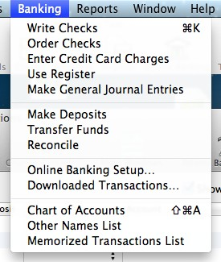1. Choose the Banking menu > Online Banking Setup.

2. Enter the name of the financial institution.

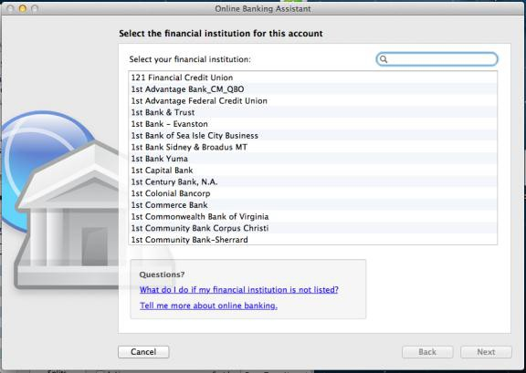

3. Choose your financial institution and click Next.

4. Follow the instructions in the wizard. If prompted for connectivity type, select
Direct Connect.

5. The Online Banking Assistant window displays during setup. Select Yes, my account has been activated for QuickBooks online services, then click Next.

6. Enter credentials and click Sign In.

7. For each account you wish to download into QuickBooks, click Select an Account
to connect to the appropriate existing account register.

8. Click Next and then click Done.

Set Up an Account for Online Banking (Web Connect)

Note: For more information on Web Connect setup, please see:
http://www.qblittlesquare.com/2012/04/online-banking-using-web-connect/

1. Log in to your financial institution’s (FI’s) web site. Download your transactions according to your financial institution’s instructions. You will need to select the download type for QuickBooks, such as “QuickBooks Web Connect (*.QBO).”

Note: The Mac operating system should save the file to a default location. Please make note of this location for the next steps.

2. Open QuickBooks and your Company file, then choose the Banking menu >
Downloaded Transactions > Import File.

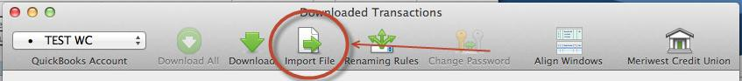

You will then see an import dialog.

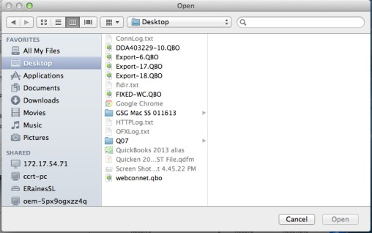

3. Navigate to and select the file you downloaded in Step 1, then click Open.

You will see a dialog like this one, with your FI information.

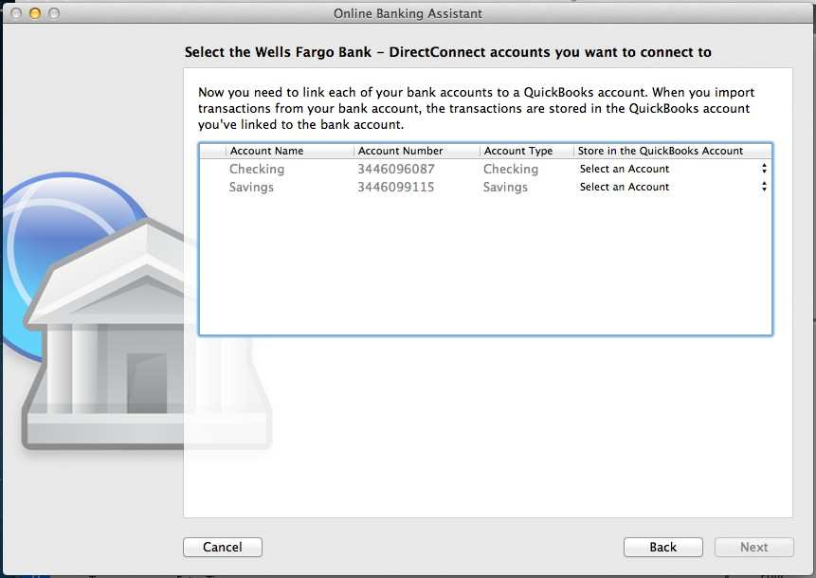

4. Click on Select an Account for each account and choose which account in QuickBooks to connect it to. If you do not yet have an account in QuickBooks to connect with, you can select New… as shown below.

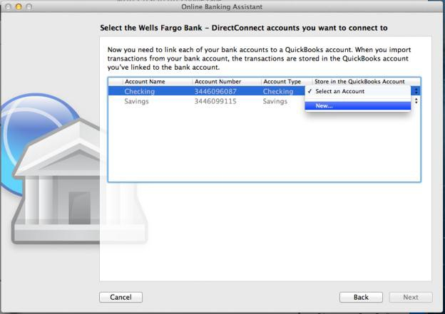

5. After creating a new account, you may need to click Select an Account again and select the new account.

6. When done, click Next at the bottom.

7. You will receive a message that you have successfully set up your accounts. Click
Close to return to the Downloaded Transactions window.

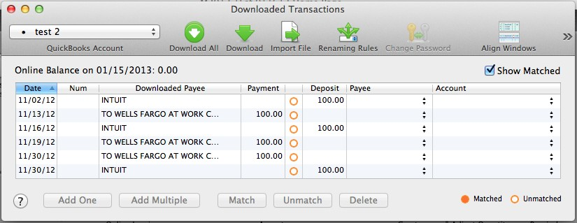Updating Accounts

Updating an Account (Direct Connect)

1. Choose Banking menu > Downloaded Transactions.

2. Click Download to update only the selected account, or Download All to update all of your accounts activated for online banking.

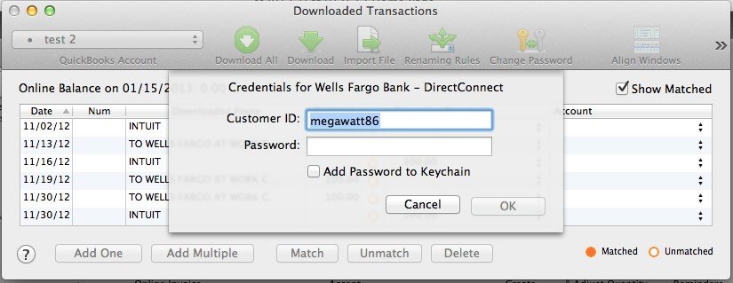3. QuickBooks will open a window to enter the account PIN or password supplied by your financial institution. Enter this and then click OK.

Note: You can choose to add your online banking password to your Mac OS Keychain, but this is not required.

QuickBooks will then connect and synchronize online banking transactions with the financial institution.

4. When done, QuickBooks will give you a count of how many transactions were imported. Click OK when ready.

5. QuickBooks will then return to the Downloaded Transactions window and open the register for the selected account so that you can begin the transaction matching process.

Updating an Account (Web Connect)

1. Choose the Banking menu > Downloaded Transactions.

2. Select the Web Connect account you want to update in the drop down menu toward the upper left corner. Then click Download.

Note: For Web Connect accounts, QuickBooks will open your financial institution (FI) website. Please log in and download the QuickBooks web connect file (*.QBO) per the financial institution’s instructions. Alternately, you can log into the FI website outside of QuickBooks and follow the same steps below.

3. When you begin the web connect download from the FI website, your web browser should give you the option to either “open” the file or “save” it.

• If you open it, QuickBooks will take over and begin the import process.

• If you save it, you can import it later using the Import File button in the
Downloaded Transactions window.

QuickBooks will then import the online banking transactions.

4. When done, QuickBooks will give you a count of how many transactions were imported. Click OK when ready.

5. QuickBooks will then return to the Downloaded Transactions window and open the register for the selected account so that you can begin the transaction matching process.

Special Note 1: Matching and Adding Transactions

Note: For more information on transaction matching, please see:
http://www.qblittlesquare.com/2012/04/online-banking-updating-your-register-2/

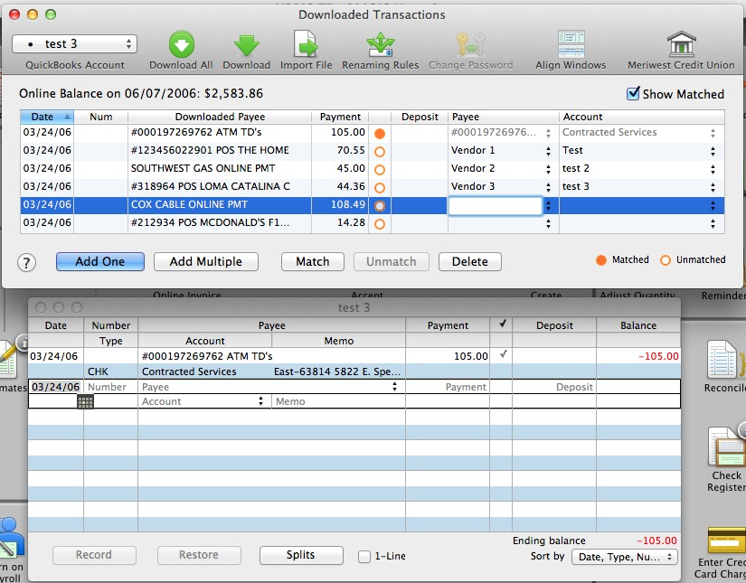1. Choose Banking menu > Downloaded Transactions.

2. Click the Financial Institution drop-down menu and choose your financial institution
(FI).

3. Use the buttons at the bottom of the Downloaded Transactions window to add downloaded transactions to the account register add multiple at one time, match them to transactions already in the register and more.

4. For detailed instructions on how to match and add transactions go to the QuickBooks Help menu, and use the search field at the top to search for “Match Transactions,” then select the article Online Banking: Updating your Register. Or, you can use the links in the next section for online resources and information.

Special Note 2: Other Resources

Here are links to other resources that Intuit makes available to help customers with Online
Banking in QuickBooks for Mac:

Intuit’s QB Little Square Site: Dedicated to QuickBooks Mac Users
www.qblittlesquare.com

Online Banking: Updating your Register
http://www.qblittlesquare.com/2012/04/online-banking-updating-your-register-2/

Online banking: Tips and troubleshooting
http://www.qblittlesquare.com/2012/04/olbtroubleshooting/

Online banking: Renaming rules for payee names
http://www.qblittlesquare.com/2012/04/post-096/

Video: Renaming rules and Add Multiple with online banking
http://www.qblittlesquare.com/2012/04/online-banking-renaming-rules/

WebConnect vs. DirectConnect
http://www.qblittlesquare.com/2011/12/webconnect-versus-directconnect/

