QuickBooks 2013 Getting Started

Financial Institution Support - OFX Connectivity Group

Table of Contents

QUICKBOOKS 2013 FOR WINDOWS GETTING STARTED GUIDE .............................. 3

ABOUT THIS GUIDE .................................................................................................. 3

THE QUICKBOOKS INTERFACE .................................................................................... 3

QUICKBOOKS 2013 ONLINE BANKING CENTER INTERFACE............................................... 4

QUICKBOOKS 2012 ONLINE BANKING CENTER INTERFACE............................................... 4

WHAT YOU NEED TO GET STARTED......................................................................... 5

SET UP AN ACCOUNT FOR ONLINE BANKING (DIRECT CONNECT)........................................ 5

SET UP AN ACCOUNT FOR ONLINE BANKING (WEB CONNECT) ........................................... 6

THE ONLINE BANKING CENTER AND ONLINE BANKING MODES ............................. 8

ONLINE BANKING CENTER (SIDE-BY-SIDE MODE) ......................................................... 8

UPDATING AN ACCOUNT (DIRECT CONNECT) ................................................................. 8

UPDATING AN ACCOUNT (WEB CONNECT) ................................................................... 10

SPECIAL NOTE: MATCHING AND ADDING TRANSACTIONS .................................. 11

MATCH DOWNLOADED TRANSACTIONS........................................................................ 11

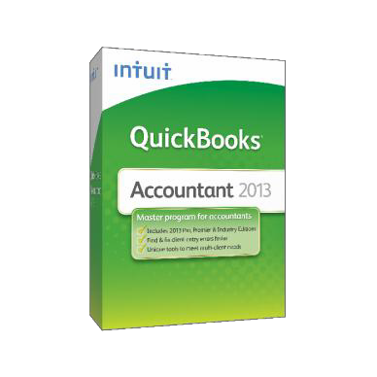QuickBooks 2013 for Windows Getting
Started Guide

Thank you for choosing QuickBooks!

About this Guide

This guide helps you get started with QuickBooks as quickly as
possible. You’ll learn:

• What you will need to get started

• How to set up an account for online banking (Direct Connect)

• How to set up an account for online banking (Web Connect)

• An overview of online banking modes and the Online Banking Center

• How to update an account (Direct Connect)

• How to update an account (Web Connect)

The QuickBooks Interface

The QuickBooks 2013 Interface has changed, but banking commands are still easy to find.

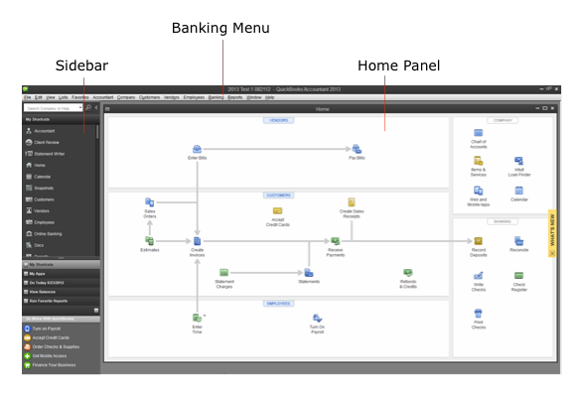

QuickBooks 2013 Online Banking Center Interface

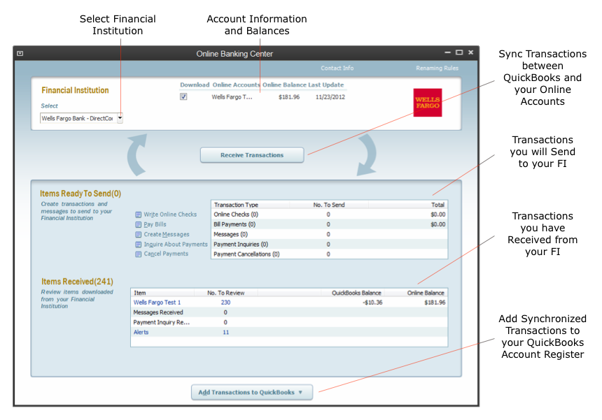The QuickBooks 2013 Online Banking center (Side-by-side mode shown below) is a one- stop-shop to monitor your online banking activity and synchronize transactions.

QuickBooks 2012 Online Banking Center Interface

Previous versions of QuickBooks had a similar OBC interface.

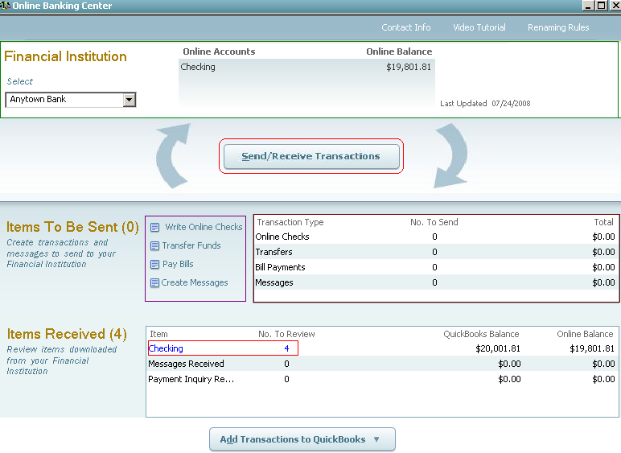

What You Need to Get Started

Before you enable your QuickBooks accounts to download transactions and make online payments, you may need to contact your financial institution (FI) for the following information:

• Customer ID

• Personal Identification Number (PIN) or password

NOTE: For QuickBooks Web Connect accounts, the customer ID and PIN/password you will need are the same as the ones you use currently to log into the financial institution website. For Direct Connect they may be the same or not. Please contact your financial institution to verify your Direct Connect login information.

It is recommended that you take these steps first:

• Back Up Your QuickBooks Data File.

For instructions to back up your data file, please choose Help menu >
QuickBooks Help. Search for Back Up and follow the instructions.

• Download the latest QuickBooks update.

For update instructions, choose Help menu > QuickBooks Help. Search for Update QuickBooks, then select Updating QuickBooks, or Update QuickBooks, and follow the instructions.

• Switch to single user mode, if you are sharing the QuickBooks data file among multiple computers.

For instructions to switch to single user mode, choose Help menu > QuickBooks
Help. Search for Switch to Single User Mode and follow the instructions.

Set Up an Account for Online Banking (Direct Connect)

1. Choose Banking menu > Online Banking > Set Up Account for Online
Services.

2. Select an account to activate and click Next.

3. Choose your financial institution and click Next.

4. Follow the instructions in the wizard. If prompted for connectivity type, select
Direct Connect.

5. Select the appropriate account you want to match with the QuickBooks account selected in step 2, and click Finish.

6. Repeat steps 1 – 5 for all accounts at your financial institution.

Set Up an Account for Online Banking (Web Connect)

1. Log in to your financial institution’s (FI’s) web site. Download your transactions according to your financial institution’s instructions. You will need to select a download type for QuickBooks, such as “QuickBooks Web Connect (*.QBO).”

Note: These instructions assume you will “save” the download to a location on your computer. If you “open” it instead, your web browser should open QuickBooks begin to import the transactions. It is strongly recommended you have the desired QuickBooks Company file open in QuickBooks before you begin the download process in this scenario.

2. Open QuickBooks and your Company file, then choose Banking menu > Online
Banking > Import Web Connect File.

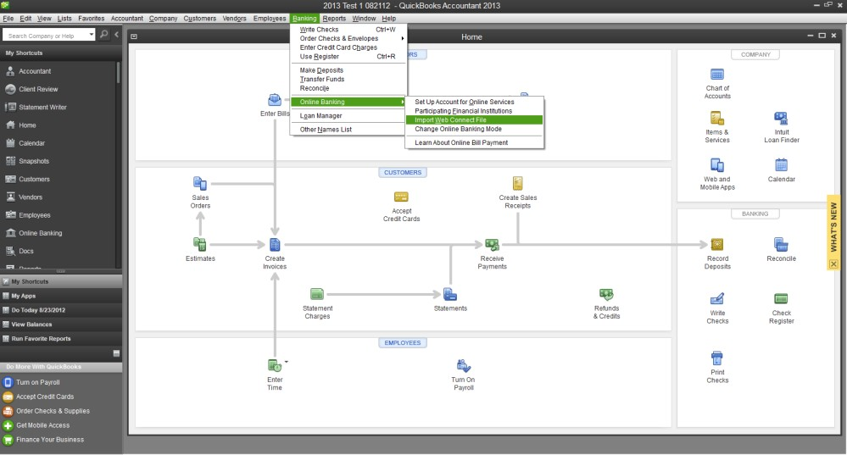

You will see an import dialog.

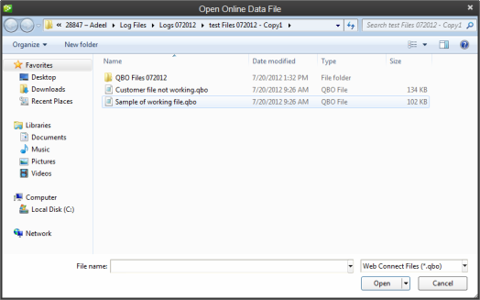

3. Navigate to and select the file you downloaded in Step 1, then click Open.

You will see a dialog like this one, with your FI information.

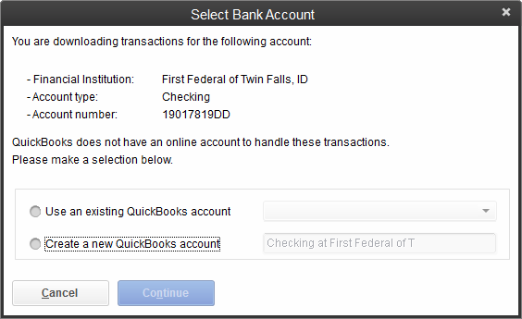

4. Select the Use an Existing QuickBooks Account radio button if you already set up an account in the Chart of Accounts. If you don’t have a an account yet, click Create a new QuickBooks account.

5. Click Continue.

6. Click OK to confirm and finish the set up.

The Online Banking Center and Online Banking Modes

QuickBooks allows you to select your display mode for online banking. The first time you set up an account for online banking, you will be prompted to set the display mode; either Side- by-side or Register mode.

For an overview of online banking modes in QuickBooks for Windows, you can view this support article: http://support.quickbooks.intuit.com/support/pages/inproducthelp/Core/QB2K12/ContentPa ckage/Services/Online_Bank_Register/olb_ov_modes.html.

Or, you can find information about these modes and how to change them by selecting Help menu > QuickBooks Help. Search for Online Banking Modes, then select Online Banking Modes overview.

This guide focuses on the Side-by-side mode. This is the newest mode with the most advanced features.

Online Banking Center – Side-by-side Mode

Starting with QuickBooks 2009, the Online Banking Center in Side-by-side mode has had several updates to allow you to better manage all of your online banking tasks in one place.

1. To get to the Online Banking Center go to Banking menu > Online Banking >
Online Banking Center.

You will use the Online Banking Center to keep your QuickBooks accounts up to date.

2. You can click the Send/Receive Transactions button to synchronize transactions with your financial institution (more information below).

3. The Add Transactions To QuickBooks window allows you to match downloaded transactions to existing ones in your account register and add new transactions (see the special note at the end of this document for more information).

Updating an Account (Direct Connect) – Side-by-side Mode

1. Choose Banking menu > Online Banking > Online Banking Center.

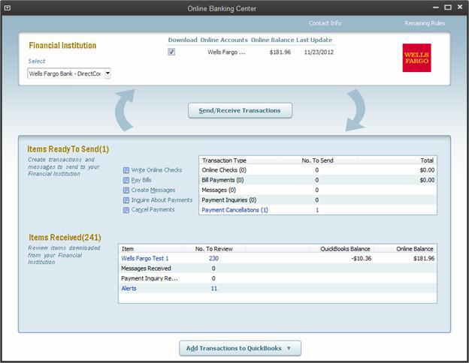2. Click Send/Receive Transactions.

3. QuickBooks will open a window to enter the account PIN or password supplied by your financial institution. Enter your code and then click OK.

QuickBooks will then connect and synchronize online banking transactions with the financial institution.

4. Review the Online Transmission Summary. Click Print, if desired. Click Close
when done.

5. In the Items Received section, click on the FI statement name to proceed to transaction matching when ready. Alternately, you can click Add Transactions to QuickBooks to begin matching.

Updating an Account (Web Connect) – Side-by-side Mode

1. Choose Banking menu > Online Banking > Online Banking Center.

2. Click Send/Receive Transactions.

NOTE: For Web Connect accounts, QuickBooks will open your financial institution (FI) website. Please log in and download the QuickBooks web connect file (*.QBO) per the financial institution’s instructions. Alternately, you can log into the FI website outside of QuickBooks and follow the same steps below.

3. When you begin the web connect download from the FI website, your web browser should give you the option to either “open” the file or “save” it.

• If you open it, QuickBooks should open and begin the import process.

• If you save it, you can import it later (see http://support.quickbooks.intuit.com/support/pages/inproducthelp/core/qb2k12/co ntentpackage/services/online_bank_register/task_webconnect_import_ofx_file.htm l).

QuickBooks will then import the online banking transactions.

4. Review the Online Transmission Summary. You can print the summary or just click
Close when done.

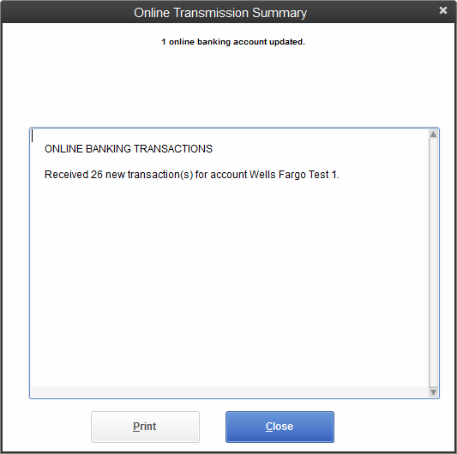

5. In the Items Received section, click on the FI statement name to proceed to transaction matching when ready.

Special Note: Matching and Adding Transactions

Overview of Handling Downloaded Transactions (Side-by-side mode)

1. Choose Banking menu > Online Banking > Online Banking Center.

2. Click the Financial Institution drop-down menu and choose your financial institution
(FI).

3. Go to the Items Received list and click the name of the FI statement you want to review, or click Add Transactions to QuickBooks.
4. Follow the instructions in the Add Transactions to QuickBooks window. a) The Add Transactions To QuickBooks window allows you to match
downloaded transactions to existing ones in your account register and add new ones.

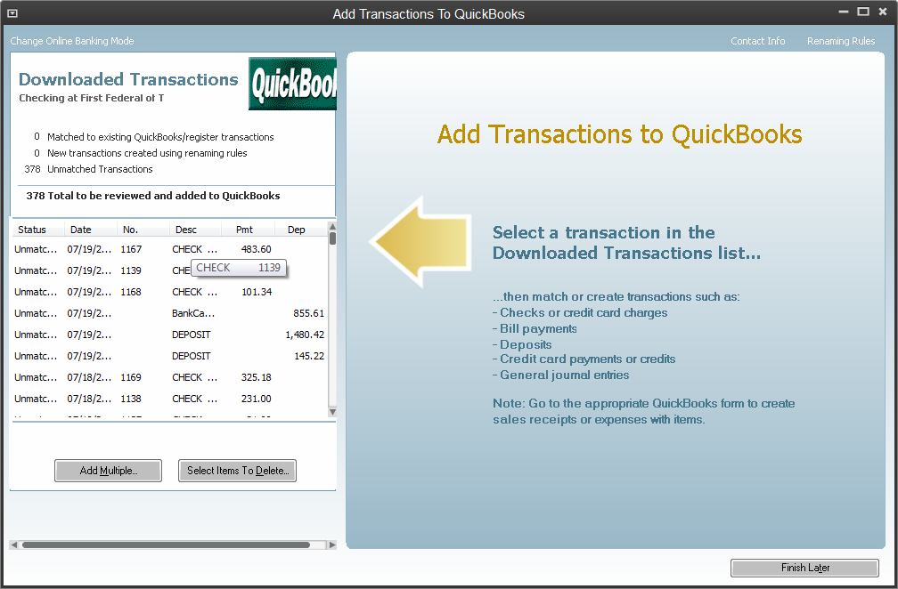

b) For example, you can click on a transaction you wish to add to QuickBooks, follow the prompts to ensure accuracy, and then click Add to QuickBooks to add it immediately to your account register.

For more information about matching transactions, choose Help menu > QuickBooks Help. Search for Matching Transactions and follow the instructions.

Or, you can find more information in these online support articles: http://support.quickbooks.intuit.com/support/Articles/HOW12832 and http://support.quickbooks.intuit.com/support/pages/inproducthelp/core/qb2k12/co ntentpackage/services/online_bank_register/task_match_transactions.html?family
=pro

