GETTING STARTED WITH QUICKEN® Express Web Connect and Web Connect

Refer to this guide for instructions on how to use Quicken’s online account services to save time and automatically keep your records up to date. This guide will be broken up into product versions, please be sure to follow the steps that apply to the version of Quicken you are currently utilizing.
Before you can download your transactions with Quicken you will need internet access, your customer ID and
password. *

Your Quicken customer ID and password are the same as the ones that you use to log in to Bank of Botetourt’s Online
Banking website.

This Getting Started Guide contains the following information:

• Downloading the Latest Quicken Updates- How to download free product updates as they become available for your version of Quicken.

• Creating a New Quicken Account- How to use the Express Setup to create a new Quicken account for downloading transactions and paying bills online.

• Keeping Your Quicken Accounts Up to Date- How to download transactions or send payments with accounts that you have activated for online account services.

• Using Online Bill Payment- How to set up an online payee and create an online payment.

For step-by-step instructions with an online task (or any other Quicken question) go to Help -7 Quicken Help -7 select the Search
Quick Help tab and type in the topic and click Ask.

DOWNLOADING THE LATEST QUICKEN® UPDATE

1. Click the Update icon on the Quicken toolbar.

2. Uncheck all boxes -7 Update Now in the One Step Update Settings dialog.

3. If an update is available, Quicken will provide a description of the update and brief instructions for receiving the update.
4. When the update is completed, close Quicken. Reopen Quicken.

DOWNLOAD OPTION

Direct Connect vs. Express Web Connect vs. Web Connect: Quicken offers several methods for you to connect to your financial institution.
• Direct Connect provides a direct connection to your financial institution, and allows you to download transactions, as well as initiate transfers and bill payments directly from Quicken, without having to log into your bank website. Not all financial institutions support Direct Connect. Some financial institutions may charge an additional fee for this service. If you are interested in Direct Connect, please contact your financial institution to activate it before you set up your account in Quicken. Once you receive your Direct Connect login information, enter it in this screen.
• Express Web Connect allows you to download transactions automatically from your bank, but does not enable transfers or bill payments. Your login is the same as what you use to login on your bank website. Access and retrieval of data is automated through the use of scripts and nightly aggregation. During aggregation, Quicken logs in to your online banking web site on your behalf.
• Web Connect allows you to download your transactions directly from your bank's website and import them into Quicken. In this case, there is no real communication going on between your Quicken software and your bank

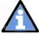Quicken automatically tries to pick the best method to connect to your financial institution. When you enter a login on this screen, Quicken will try Direct Connect, and if that doesn’t work, will default to Express Web Connect. If that doesn’t work, you will be taken to
the login page of your financial institution’s website.

CREATING A NEW QUICKEN ACCOUNT 2014

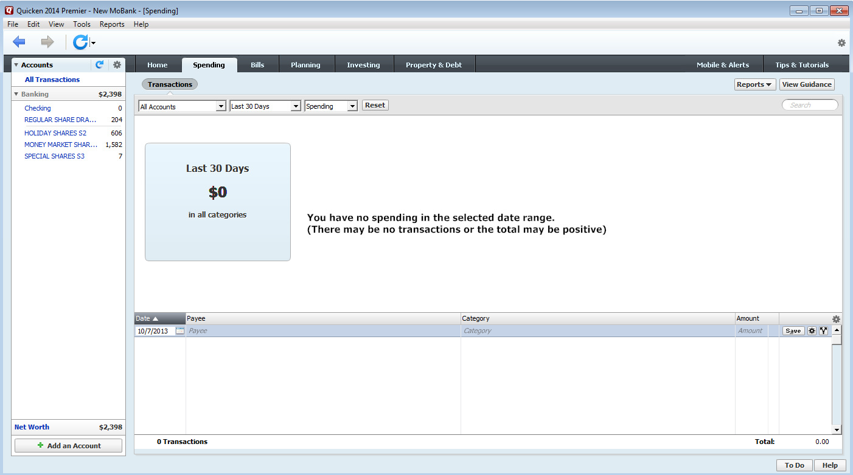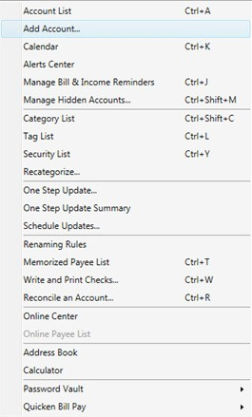1. To add a new account -7 Click on the Tools drop down menu -7 then select the Add Account option or Click the Add an Account button

2. On the Add Account window select the type of account you will be setting up -7 Enter your financial institution’s name

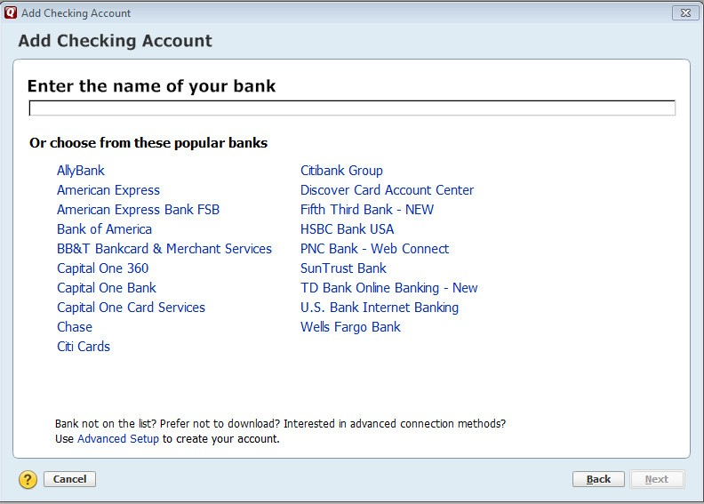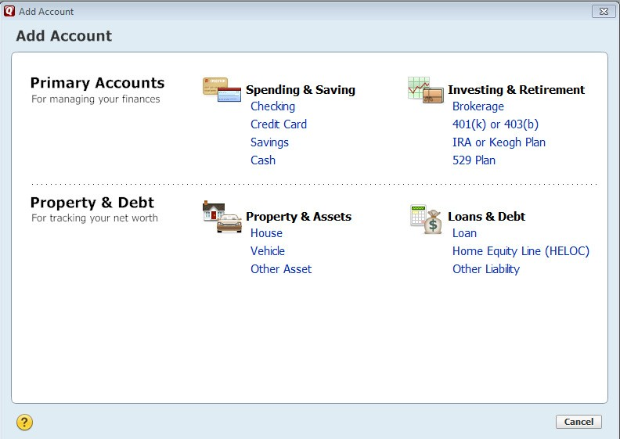

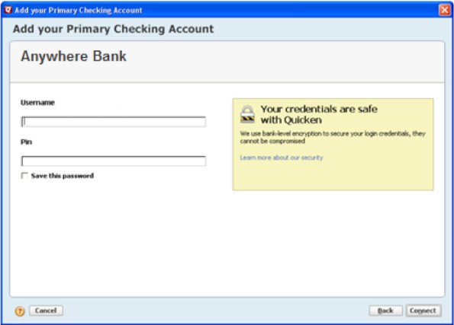3. Enter your bank login information; this will be the same UserID/Password as your financial institution’s website. Click Connect

Getting Started Guide QW Last Updated 9/2013

By selecting Advanced Setup you will able to select the option to download transaction
directly from your financial institution’s

4. All downloadable Quicken accounts display. You can choose to add another account right now or start using Quicken and add more accounts later.

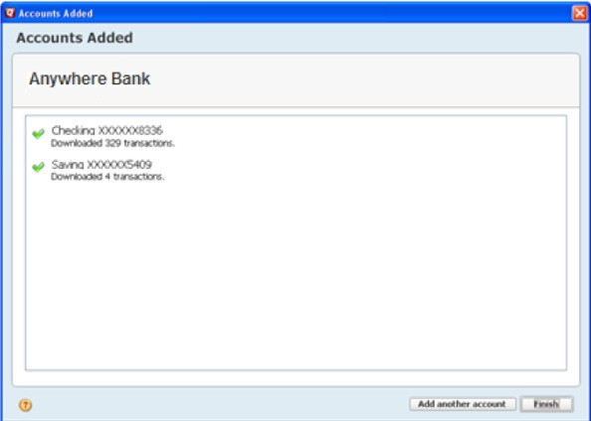

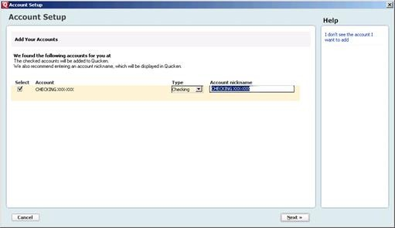5. Quicken will download your transactions and automatically categorize them, so you can quickly see where your money is going.

To customize the Account Name in Quicken, enter account nickname

CONGRATULATIONS! YOU ARE SET UP AND READY TO USE QUICKEN

If you have any questions regarding these instructions, you may also refer to: http://www.intuit.com/support/quicken.

Getting Started Guide QW Last Updated 9/2013

